**Docker Networking Hands-on Lab**

Time spent: 60 min

# Networking Basics

# Network command

# 

# Inspect a network

# 

# Bridge Networking

# Basics

# 

# Connect a container

# 

# Overlay Networking

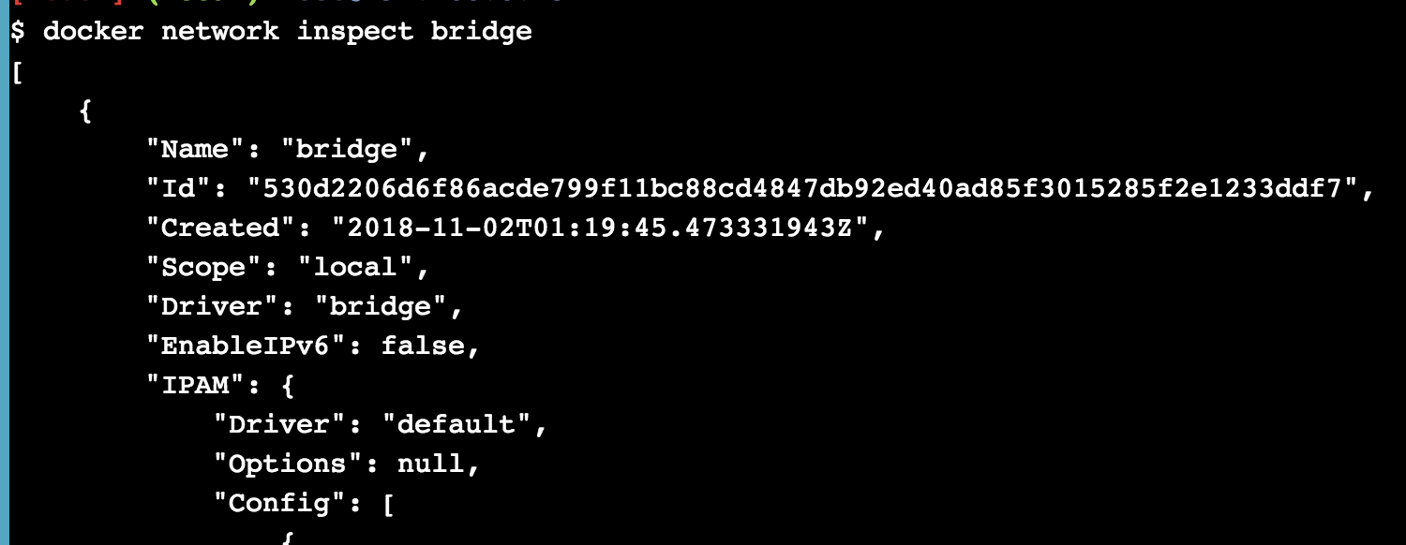

**Summary**

In this lab, I have learned the knowledge about network in the container.